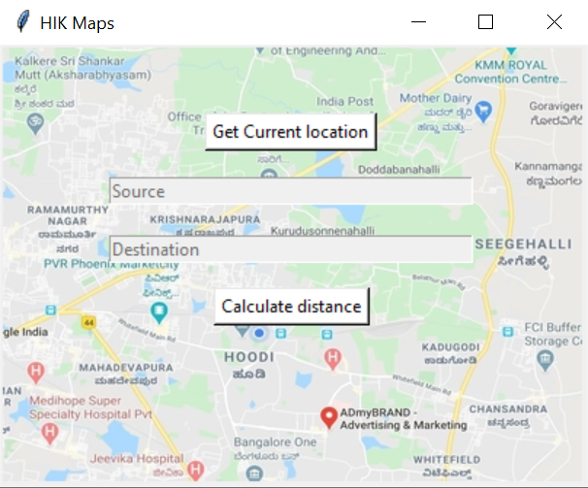

***Fig1:*** *GUI of the application*

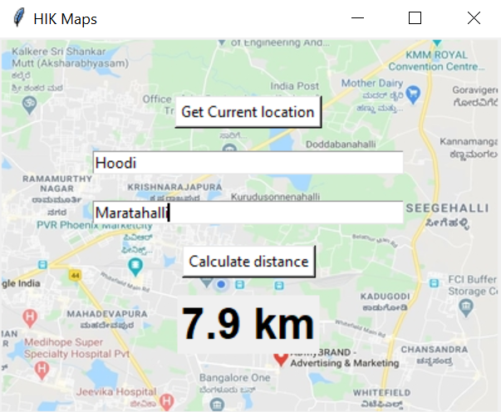

***Fig2:*** *Distance between two places*

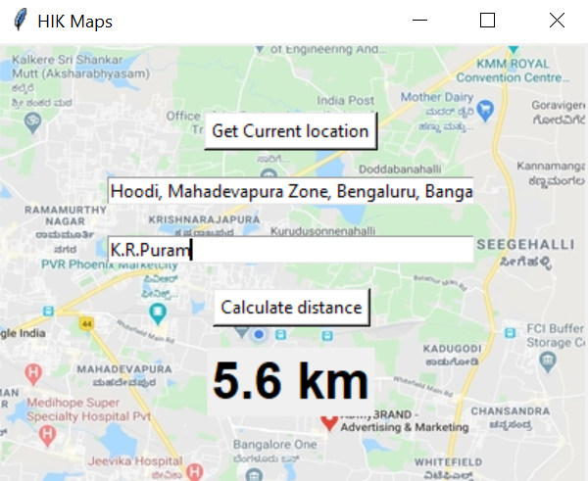

***Fig3:*** *Distance between current location and required destination*